Step 0 Intake + Interview Filing Status, Dependency
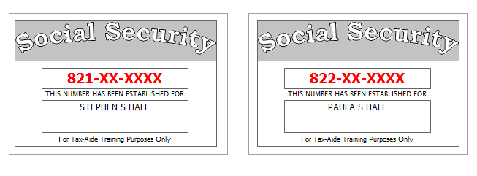
Stephen’s sister, Wanda Winters, is totally and permanently disabled and relies upon her brother for her support. She receives $250 per month in social security benefits. She is covered by Medicare.
Paula has less than 20/200 vision in both eyes. She provided a doctor’s statement.
Reference: 4012 Tab A, B, C
Tool: IRS Interactive Tax Assistant (link on Preparer page)
Tool: AARP Resource Tool for Counselors (Laminated Flow Chart)
Tool: TP4F Qualifying Child/Qualifying Relative Flowchart Tool (link on Preparer page)
Tool: Dependent Calculator (link on Preparer page)

Step 1 Basic Information
Use the Filing Status from Step 0
Use Intake Sheet and Social Security cards
Extra Interview information for New Jersey:
- All dependents have health insurance (as of the time the return is filed)
- The Hales want their contribution to the Gubernatorial Election Campaign Fund to be handled the same as their contribution to the Presidential Election Campaign Fund.
Reference: 4012 K-3 to K-4
Tool: NJ Municipality Code Lookup Tool (link on Preparer page)
Tool: NJ 1040 Instructions – Municipality Code Table
Hint: For Profile, use Basic (No Profile)
Hint: Use names from SS Cards (NOT Intake Sheet)
Hint: A simple NJ return will be added after filling in the Federal Personal Information screen. Answer only the subset of the NJ Basic questions asked
Hint: Do not go to the State Section and do anything until you are done with the Federal Section and Health Insurance sections. Use the NJ Checklist to record things you will need to remember when doing the State Section later.
Hint: You do not need to remember or record the NJ PIN
NJ: Fill in Basic Information section of NJ Checklist now
Federal Refund: 0 NJ Refund Amount: 0

Step 2a Prior Year Return – State Income Taxes paid
Although they received a federal refund on last year’s return, they owed $203 to NJ (which they paid on time). The also owed $42 from their NJ return from three years ago, which they paid on 06-15-2015.
Hint: Search for “STATE” and select “Go to Form Additional Paid State Tax now”
Federal Refund: 0 NJ Refund Amount: 0
Step 2b Prior Year Return – Capital Loss Carryover
Their prior year return (not prepared at your site) shows a long-term capital loss carryover of $12,454. There is no short-term capital loss carryover.
Federal Refund: 0 NJ Refund Amount: 0
Step 3 1099-R
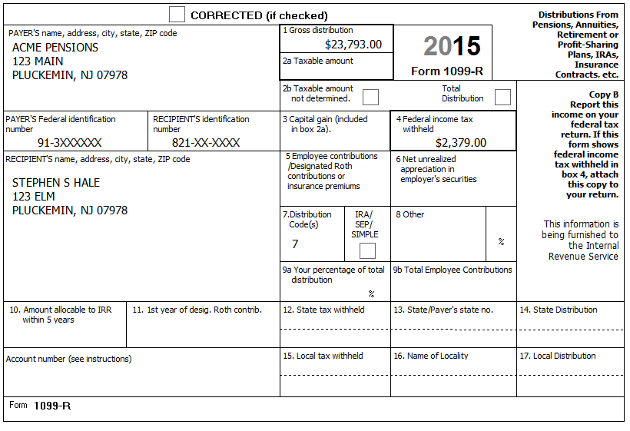
Federal Refund: 2,379 NJ Refund Amount: 0
Step 4 CSA 1099-R
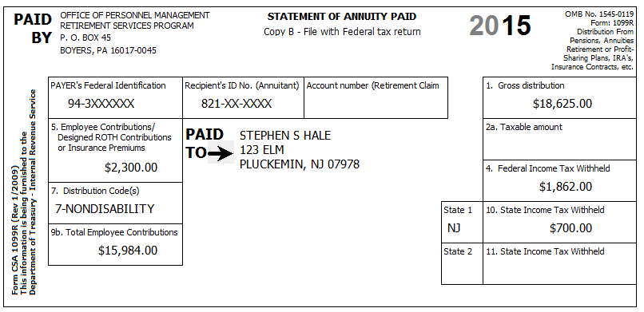
Stephen started receiving this pension on February 1, 2008. Paula is also covered by the plan.
They confirm that the amount in Box 5 is for medical insurance.
Tool: Annuity Calculator (link on Preparer page)
Hint: Use the Annuity Calculator to figure out the entries for the TSO Simplified Method worksheet
NJ: Add untaxed portion (Box 1 – Box 2a) to NJ Checklist (Adjustments to Line 19b)
Step 4a Form 1099-R
Federal Refund: 3,073 NJ Refund Amount: 472
Step 4b Schedule A – Medical Deductions
BP: Enter the insurance costs on Sch A now (to avoid forgetting to do so later)
Federal Refund: 3,073 NJ Refund Amount: 498
Q: Why did NJ Refund go up?
Step 5 1099-R
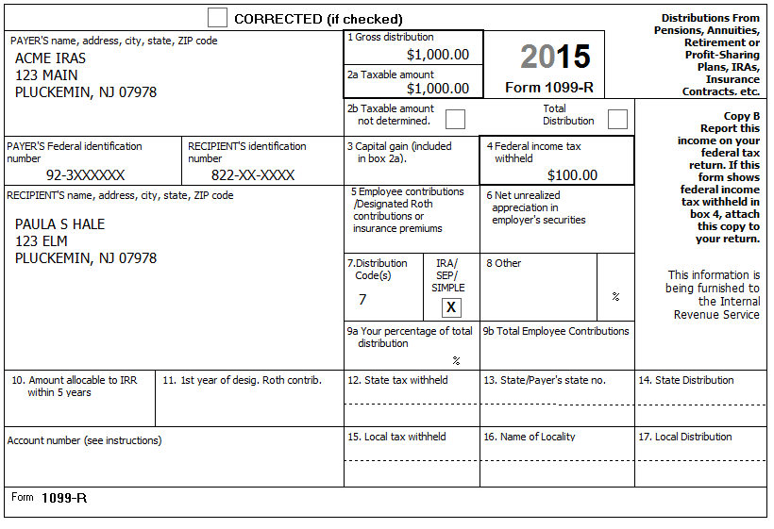
Federal Refund: 3,073 NJ Refund Amount: 483
Q: Paula took this distribution in November – What would change if she had taken it in June?
Q: Why didn’t the Federal Refund change?
Step 6 SSA-1099 – Stephen
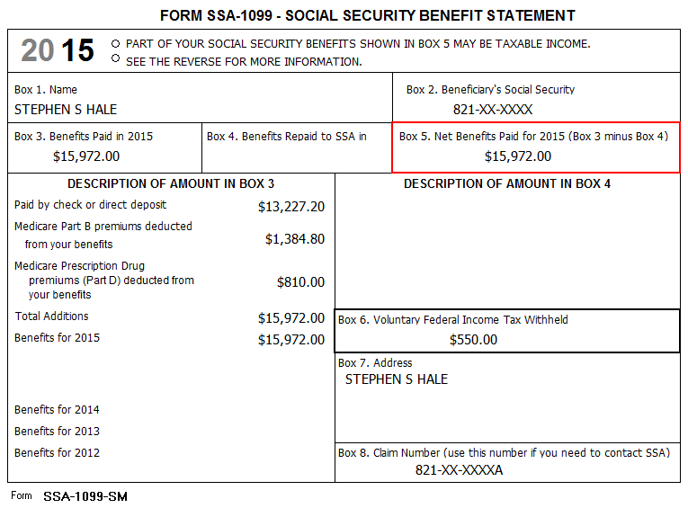
Federal Refund: 2,525 NJ Refund Amount: 514
Q: Social Security is not taxable in NJ - Why did the NJ Refund change?
Step 7 K-1
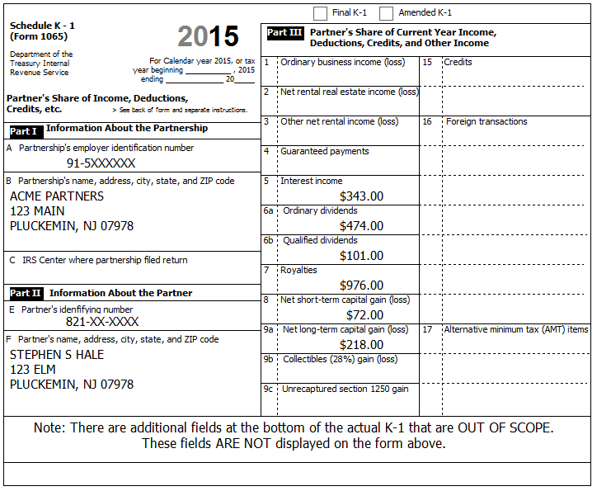
In addition to the above, Box 18a shows $31.00 of Tax Exempt Interest Income. This amount is all from Tax-exempt Federal obligations
You determine that a) This is a Passive Entity, b) All Investment is At-Risk, c) The entire investment has not been disposed, and d) This is not a PTP
Reference: 4012 D-53 to D-54
xTWO Hint: Direct entry on Schedule K-1 (Other Income) Input screen is ok in TSO. (and Sch E will be created automatically, if necessary)
Federal Refund: 2,037 NJ Refund Amount: 485
Check: Fed 1040, line 8a=343; 8b=31; 9a=474; 9b=101
Check: NJ-1040, line 15a=343; 15b=31; 16=474

Step 8 Brokerage Statement Page 1 of 4 – 1099-INT
Acme Brokerage | End of Year Tax Information Statement  Tax Year 2015 • Account 203040506 | Statement Date: 01-30-2016  Page 1 of 4 | 2015
123 Main  P.O. Box 07978-123  Pluckemin, NJ 07978  PAYER’S Federal ID No: 92-2XXXXXX | Stephen S. Hale  123 Elm  Pluckemin, NJ 07978  RECIPIENT’S ID No: 821-XX-XXXX | Your Broker:  SERGE BRONSKI  888-555-5555  sbronski@acme.com

Interest Income – 1099-INT – Reported to IRS
1 | Interest Income (not included in line 3) | 124.73
2 | Early withdrawal penalty | 0.00
3 | Interest on US Savings Bonds & Treasury obligations | 506.00
4 | Federal Income tax withheld | 50.00
5 | Investment expenses | 0.00
6 | Foreign tax paid | 0.00
7 | Foreign country or US possession
8 | Tax-exempt interest (includes line 9) | 337.86
9 | Specified private activity bond interest (AMT) | 4.00
10 | Tax-exempt bond CUSIP numbers (see instructions)
11 | State
12 | State ID numbers
13 | State tax withheld | 0.00
 | FATCA filing requirement | NO

Interest Detail (only summary 1099-INT reported to IRS)
Date | 1 Interest Income | 2 Early withdrawal penalty | 3 Interest on US Savings Bonds | 4 Federal withholding | 8 Tax-exempt interest
Safe Stuff
12-30-2015 | 124.73 | 0.00 | 506.00 | 50.00 | 0.00
New Jersey Muni Bond
12-30-2015 | 0.00 | 0.00 | 0.00 | 0.00 | 148.64
New York Muni Bond
12-30-2015 | 0.00 | 0.00 | 0.00 | 0.00 | 189.22
Totals: | 124.73 | 0.00 | 506.00 | 50.60 | 337.86

The Savings Bond interest was not used for any tax-exempt purpose.
Note: There are three separate sub-steps (Screens) necessary to handle this document

Step 8a Interest Income Screen
Federal Refund: 1,915 NJ Refund Amount: 483
Check: Fed 1040, line 8a=974; 8b=31; 9a=474; 9b=101
Check: NJ-1040, line 15a=468; 15b=537; 16=474
Step 8b Tax-Exempt / Schedule B Other Interest Screen
Federal Refund: 1,870 NJ Refund Amount: 480
Q: The interest entered was tax-exempt federally - Why did the Federal Refund change?
Check: Fed 1040, line 8a=974; 8b=369; 9a=474; 9b=101
Check: NJ-1040, line 15a=657; 15b=686; 16=474
Step 8c Form 6251
Hint: 1099-INT, Line 9 goes on Form 6251 (Line “Interest from specified private activity bonds exempt from the regular tax”) in TSO (search for 6251 or AMT)
Federal Refund: 1,870 NJ Refund Amount: 480

Step 9 Brokerage Statement Page 2 of 4 – 1099-DIV
Acme Brokerage | End of Year Tax Information Statement  Tax Year 2015 • Account 203040506 | Statement Date: 01-30-2016  Page 2 of 4 | 2015
123 Main  P.O. Box 07978-123  Pluckemin, NJ 07978  PAYER’S Federal ID No: 92-2XXXXXX | Stephen S. Hale  123 Elm  Pluckemin, NJ 07978  RECIPIENT’S ID No: 821-XX-XXXX | Your Broker:  SERGE BRONSKI  888-555-5555  sbronski@acme.com

Dividends and Distributions – 1099-DIV – Reported to IRS
1a | Total ordinary dividends (includes line 1b) | 231.86
1b | Qualified dividends | 125.25
2a | Total capital gain distributions (includes lines 2b, 2c, 2d) | 68.75
2b | Unrecaptured Section 1250 gain | 0.00
2c | Section 1202 gain | 0.00
2d | Collectibles (28%) gain | 0.00
3 | Nondividend distributions | 32.44
4 | Federal Income tax withheld | 80.00
5 | Investment expenses | 0.00
6 | Foreign tax paid | 43.75
7 | Foreign country or US passion
8 | Cash liquidation distributions | 0.00
9 | Noncash liquidation distributions | 0.00
10 | Exempt-interest dividends (includes line 11) | 400.00
11 | Specified private activity bond interest dividends (AMT) | 22.00
12 | State
13 | State ID number
14 | State tax withheld | 0.00
 | FATCA filing requirement | NO

Dividend Detail (only summary 1099-DIV reported to IRS)
Date | 1a Ordinary dividends | 1b Qualified dividends | 2a Capital gains | 3 Nondiv. Dists. | 4 Federal w/h | 6 Foreign tax paid | 10 Exempt Interest | 11 Sp. PAB
Boring Mutual Fund (BMF)
12-30-2015 | 231.86 | 125.25 | 68.75 | 32.44 | 0.00 | 43.75 | 0.00 | 0.00
Select US Tax-Exempt Fund (SUSTE)
12-30-2015 | 0.00 | 0.00 | 0.00 | 0.00 | 0.00 | 0.00 | 200.00 | 0.00
Select NJ Qualified Fund (SNJQTE)
12-30-2015 | 0.00 | 0.00 | 0.00 | 0.00 | 0.00 | 0.00 | 200.00 | 22.00
Totals: | 231.86 | 125.25 | 68.75 | 32.44 | 0.00 | 43.75 | 400.00 | 22.00

Exempt-Interest Dividends by Area
Area | SUSTE | SNJQTE
Alabama | 1.3% | -
Alaska … Nevada | 28.2% | -
New Hampshire | 0.5% | -
New Jersey | 10.0% | 70.0%
New Mexico | 0.7% | -
New York … Wisconsin | 29.1% | 7.0%
Wyoming | 0.2% | -
District of Columbia | 0.2% | 1.0%
Puerto Rico | 9.7% | 2.0%
US Possessions | 20.1% | 20.0%
Total | 100.0% | 100.0%
Note: There are three separate sub-steps (Screens) necessary to handle this document
Step 9a Dividend Income Screen
Federal Refund: 1,949 NJ Refund Amount: 476
Check: Fed 1040, line 8a=974; 8b=369; 9a=706; 9b=226
Check: NJ-1040, line 15a=657; 15b=686; 16=706
Step 9b Tax-Exempt / Schedule B Other Interest Screen
Federal Refund: 1,896 NJ Refund Amount: 474
Check: Fed 1040, line 8a=974; 8b=769; 9a=706; 9b=226
Check: NJ-1040, line 15a=811; 15b=932; 16=706
Step 9c Form 6251
Hint: 1099-div, Line 11 goes on Form 6251 (Line “Interest from specified private activity bonds exempt from the regular tax”) in TSO (search for 6251 or AMT)
Federal Refund: 1,896 NJ Refund Amount: 474

Step 10 Brokerage Statement Page 3 of 4 – 1099-B
Acme Brokerage | End of Year Tax Information Statement  Tax Year 2015 • Account 203040506 | Statement Date: 01-30-2016  Page 3 of 4 | 2015
123 Main  P.O. Box 07978-123  Pluckemin, NJ 07978  PAYER’S Federal ID No: 92-2XXXXXX | Stephen S. Hale  123 Elm  Pluckemin, NJ 07978  RECIPIENT’S ID No: 821-XX-XXXX | Your Broker:  SERGE BRONSKI  888-555-5555  sbronski@acme.com

FORM 1099-B 2015 Proceeds from Broker and Barter Exchange Transactions
Long-term transactions for which basis is not reported to the IRS - Report on form 8949 with Box E checked
1a Description, 2 Long-term, 3 Basis not reported to IRS, 6 Net Proceeds
Quantity | 1b Date Acquired | 1c Date Sold | 1d Proceeds | 1e Cost or other Basis | 1f Code | 1g Adj | Gain / Loss(-) | 4 Federal Tax Withheld
Acme Corp (ZACO)
50.000 | 09-01-1993 | 05-10-2015 | 3,462.00 | 3.181.00 |  |  | 281.00 | 0.00
100.000 | 09-01-1993 | 10-20-2015 | 7,226.00 | 6,362.00 |  |  | 864.00 | 0.00
150.000 |  |  | 10,688.00 | 9,543.00 |  | 0.00 | 1,145.00 | 0.00
Acme Inc (ZAI)
65.000 | ** | 10-20-2015 | 5.663.00 | ** | W | 97.00 | ** | 0.00
Totals |  |  | 16,351.00 |  |  |  |  | 0.00
** Information not available

Acme Brokerage does not have a record for the purchase of ZAI stock. Stephen inherited the 65 shares from his uncle who paid $6,500 for the shares on 10/15/2006. The stock was worth $7,222 on 08/29/2015, the day his uncle died.
Federal Refund: 1,896 NJ Refund Amount: 478
Q: Why did the Federal Refund not change?
Q: Why did the NJ Refund go up?

Step 11 Brokerage Statement Page 4 of 4 – 1099-B
Acme Brokerage | End of Year Tax Information Statement  Tax Year 2015 • Account 203040506 | Statement Date: 01-30-2016  Page 4 of 4 | 2015
123 Main  P.O. Box 07978-123  Pluckemin, NJ 07978  PAYER’S Federal ID No: 92-2XXXXXX | Stephen S. Hale  123 Elm  Pluckemin, NJ 07978  RECIPIENT’S ID No: 821-XX-XXXX | Your Broker:  SERGE BRONSKI  888-555-5555  sbronski@acme.com

FORM 1099-B 2015 Proceeds from Broker and Barter Exchange Transactions
Long-term transactions for which basis is reported to the IRS - Report on form 8949 with Box D checked
1a Description, 2 Long-term, 3 Basis reported to IRS, 6 Net Proceeds
Quantity | 1b Date Acquired | 1c Date Sold | 1d Proceeds | 1e Cost or other Basis | 1f Code | 1g Adj | Gain / Loss(-) | 4 Federal Tax Withheld
Acme Corp (ZACO)
10.000 | 07-02-1999 | 01-15-2015 | 350.00 | 340.00 |  |  | 10.00 | 0.00
10.000 | 07-02-1999 | 02-15-2015 | 340.00 | 340.00 |  |  | 0.00 | 0.00
10.000 | 07-02-2000 | 03-15-2015 | 350.00 | 320.00 |  |  | 30.00 | 0.00
10.000 | 07-02-2000 | 04-15-2015 | 340.00 | 320.00 |  |  | 20.00 | 0.00
10.000 | 07-02-2000 | 05-15-2015 | 350.00 | 320.00 |  |  | 30.00 | 0.00
10.000 | 07-02-2000 | 06-15-2015 | 340.00 | 320.00 |  |  | 20.00 | 0.00
10.000 | 07-02-2000 | 07-15-2015 | 350.00 | 320.00 |  |  | 30.00 | 0.00
10.000 | 07-02-2000 | 08-15-2015 | 340.00 | 320.00 |  |  | 20.00 | 0.00
10.000 | 07-02-2000 | 09-15-2015 | 350.00 | 320.00 |  |  | 30.00 | 0.00
10.000 | 07-02-2000 | 10-15-2015 | 340.00 | 320.00 |  |  | 20.00 | 0.00
10.000 | 07-02-2000 | 11-15-2015 | 350.00 | 320.00 |  |  | 30.00 | 0.00
10.000 | 07-02-2000 | 12-15-2015 | 340.00 | 320.00 |  |  | 20.00 | 0.00
120.000 |  |  | 4,140.00 | 3,880.00 |  | 0.00 | 260.00 | 0.00
Acme Inc (ZAI)
30.000 | 07-02-2004 | 03-15-2015 | 330.00 | 300.00 |  |  | 30.00 | 0.00
30.000 | 07-02-2004 | 06-15-2015 | 330.00 | 300.00 |  |  | 30.00 | 0.00
30.000 | 07-02-2005 | 09-15-2015 | 330.00 | 340.00 |  |  | -10.00 | 0.00
30.000 | 07-02-2005 | 12-15-2015 | 330.00 | 340.00 |  |  | -10.00 | 0.00
120.000 |  |  | 1.320.00 | 1,280.00 |  | 0.00 | 40.00 | 0.00
Acme Ltd (ZALTD)
30.000 | 07-02-2004 | 03-15-2015 | 3,210.00 | 700.00 |  |  | 2,510.00 | 0.00
30.000 | 07-02-2004 | 06-15-2015 | 3,220.00 | 700.00 |  |  | 2,520.00 | 0.00
30.000 | 07-02-2005 | 09-15-2015 | 3,230.00 | 720.00 |  |  | 2,510.00 | 0.00
30.000 | 07-02-2005 | 12-15-2015 | 3,240.00 | 720.00 |  |  | 2,520.00 | 0.00
120.000 |  |  | 12,900.00 | 2,840.00 |  | 0.00 | 10,060.00 | 0.00
Totals |  |  | 18,360.00 | 8,000.00 |  | 0.00 | 10,360.00 | 0.00

Hint: Until guidance is provided by IRS/Tax-Aide, we use 12-31 as the sell date for consolidated transactions.
Federal Refund: 1,634 NJ Refund Amount: 308
Step 12 W2-G
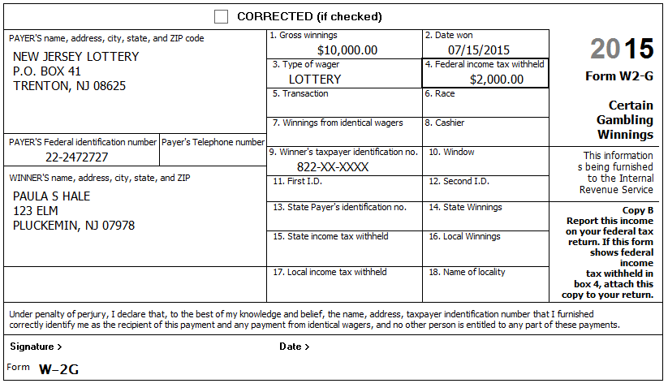
Reference: 4012 D-44
Hint: Gambling Losses ($12,000) will be entered in a later Step.
NJ: Record on NJ Checklist (NJ Line 23 – Gambling Winnings)
Federal Refund: 2,036 NJ Refund Amount: 308
Step 13 New Jersey Estimated payments
They made the following NJ estimated payments:
Tax Year | TY2014 | TY2015 | TY2015 | TY2015 | TY2015
Date | 01-03-2015 | 04-14-2015 | 06-15-2015 | 09-11-2015 | 12-28-2015
Amount | $50.00 | $60.00 | $60.00 | $60.00 | $70.00

Step 13a Schedule A – Taxes You Paid
Federal Refund: 2,036 NJ Refund Amount: 308
Step 13b Payments – State Estimated Payments
Federal Refund: 2,036 NJ Refund Amount: 558

Step 14 Notes – Itemized Deductions
Check: Before beginning this step, Use Compare Deductions to check that Itemized Deductions = 1,245
Hint: Some items in the following sub-Steps may not be deductible or may have already been entered – be alert…
Annoyance: The Compare Deductions amount does not seem to update until you click Continue enough times to take you from Deductions to Other Taxes, then go back to Deductions. Keep this in mind if you want to Check the Itemized Deductions value after each sub-step. (After the Itemized deductions amount is greater than the Standard deduction amount, you can just look at 1040, Line 40.)
Step 14a Notes – Deductions – Medical and Dental
Medicare – Part B $1,385
Medicare – Part D $810
Insurance paid by Office of Personnel Management $2,300
Insurance policy from HealthCare.gov $7,200
Doctor co-pays and deductibles $300
Long Term Care (LTC) insurance (Paula) $1,800
Reference: 4012 F-3 to F-8
Hint: The appropriate deduction amount for Marketplace (HealthCare.gov) policies can only be calculated after form 8962 has been completed – do NOT enter now – we will do this later.
Federal Refund: 2,036 NJ Refund Amount: 588
Check: After this step, Itemized Deductions = 2,447
Q: If Sch A were available, you would see that Line 1 (Medical and dental expenses) is 6,225. Why is this amount less than the total of all the medical expenses you entered?
Step 14b Notes – Deductions – Taxes You Paid
Real estate tax (Principal residence) $7,135
Real estate tax (Condo in Las Vegas) $1,865
Reference: 4012 F-3 to F-8
BP: You must click “Begin Sales Tax Worksheet” and enter State and Number of days (but not percents) even if you do not have any extra sales tax on cars, etc.
BP: Do NOT enter any NJ Property Tax recoveries (Homestead Benefit / PTR) at this point. See the notes on Step 14f for more detail.
NJ: Record appropriate Real estate tax on NJ Checklist (Property Tax)
Federal Refund: 2,036 NJ Refund Amount: 588
Check: After this step, Itemized Deductions = 11,447
Step 14c Notes – Deductions – Mortgage Interest
The Hales received a Form 1098 from Acme Mortgage related to the mortgage on their Principal residence.
Interest $2,135
Points $565
PMI $300
The Hales received a second Form 1098 from Acme Mortgage related to their Home Equity Line of Credit on their Las Vegas condo. The principal amount was $11,000.
Interest $777
Reference: 4012 F-3 to F-8
Federal Refund: 2,059 NJ Refund Amount: 588
Check: After this step, Itemized Deductions = 15,224
Step 14d Notes – Deductions – Gifts to Charity
Church cash donations with church generated listing $520
Contribution to the Chughtai Foundation with canceled check $80
Cash donations to Santa ringing bell outside grocery store (no records) $22
Donation to a political party $50
Reference: 4012 F-3 to F-8
Tool: IRS Exempt Organization Search (link on Preparer page)
Hint: Use the Exempt Organization Search tool to check if donations to the Chughtai Foundation are tax-exempt. (Just enter Chughtai in the Name search field.)
Hint: If you use the Override option for Cash, then all you need to enter is the total (no names, dates, etc.) – Just be sure to document in the TP’s paper file how you arrived at the total.
Federal Refund: 2,149 NJ Refund Amount: 588
Check: After this step, Itemized Deductions = 15,824
Step 14e Notes – Deductions – Miscellaneous
Gambling losses $12,000
Reference: 4012 F-3 to F-8
NJ: Record losses on NJ Checklist (NJ Line 23 – Gambling Winnings)
Federal Refund: 3,649 NJ Refund Amount: 588
Check: After this step, Itemized Deductions = 25,824
Step 14f Notes – Deductions – Homestead Benefit Recovery
The Hales received a Homestead Benefit of $400 applied to one of their quarterly property tax bills. The amount is shown on their printed tax bills from the township. (If they didn’t have evidence of the amount, you could look up the amount online)
The Homestead Benefit received in TY2015 is for TY2012. You do not have a copy of their TY2012 return, but they assure you that their tax situation has been pretty consistent since Stephen retired, i.e. Their Itemized deductions were several thousand dollars greater than the Standard Deduction and their taxable income was similar to this year.
Reference: New Jersey Special Handling
Tool: NJ Inquiry for Homestead Benefit (link on Preparer page)
BP: Be sure that 1) all Income, Adjustments, and Deductions have been entered, 2) The TP is using Itemized deductions rather than the Standard deduction this year before entering NJ Property Tax recovery adjustments on Sch A, and 3) The TP is still using Itemized deductions after the NJ Property Tax recovery adjustments have been made. See the flowchart in NJ Special handling for more information.
BP: Be sure to document the details of your calculation of the final Real Estate Tax amount entered into TSO.
NJ: When NJ Property Tax recovery amount is entered on Sch A, it should NOT be included on the NJ Checklist (Adjustments to Line 25)
Federal Refund: 3,589 NJ Refund Amount: 588
Check: After this step, Itemized Deductions = 25,424

Step 15 ACA Health Insurance
Stephen had Medicare all year.
Paula had a Marketplace (HealthCare.gov) policy all year.
Wanda had insurance from her former employer through December 5th of the prior year. She had COBRA coverage from February 25th to June 30th of the current year. She had Medicare from September 1st to December 31st of the current year.
Wanda did not have a federal filing requirement.
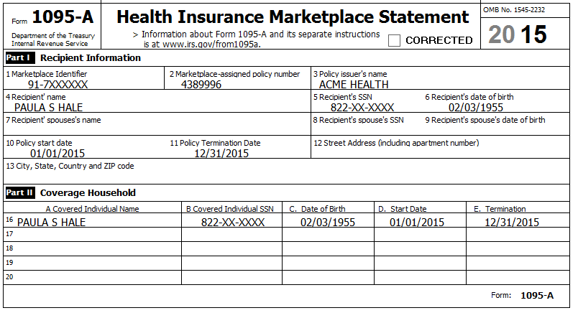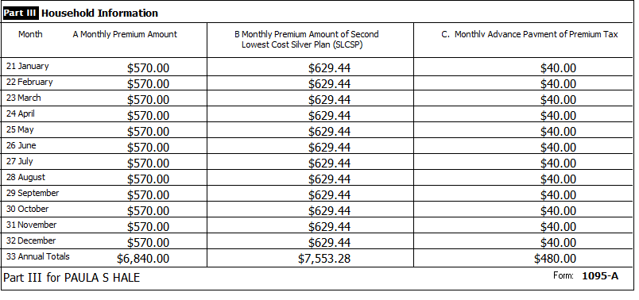
Reference: 4012 ACA Tab

Step 15a ACA Health Insurance – Health Insurance Section
Hint: Your local ACA expert says that the only exemption Wanda might qualify for during the periods when she did not have insurance is the Short Coverage Gap (Code B).
Federal Refund: 3,803 NJ Refund Amount: 588
Step 15b ACA Health Insurance – Add Sch A amount
Hint: To calculate the correct amount for Sch. A, you need to look at a couple of lines on the 1040 after completing the Health Insurance section in TSO. Use the following procedure:
- Calculate the “TY Net Premium” by subtracting the 1095-A, Column C total from the Column A total. (e.g. 6,840 – 480 = 6,360)
- Calculate the “Sch A Deduction Amount”:
  - If 1040, Line 46 (Excess advance premium tax credit repayment) has a value, add it to the “TY Net Premium”
  - If 1040, Line 69 (Net premium tax credit) has a value, subtract it from the “TY Net Premium”. (e.g. 6,360 – 367 = 5,993)
- Enter the “Sch A Deduction Amount” on the Medical Deductions screen in TSO.
BP: Be sure to document the calculation of the amount you end up entering into TSO for your Quality Reviewer and for the TP records.
Federal Refund: 4,703 NJ Refund Amount: 689

State Section (New Jersey)
You have collected information during several Federal Steps on your NJ Checklist – It is now time to enter that information into TSO
Step 16a NJ Checklist – Basic Information
Enter New Jersey State Return – Basic Information
Hint: Nothing to do here.
Federal Refund: 4,703 NJ Refund Amount: 689
Step 16b NJ Checklist – Income Subject to Tax
Enter New Jersey State Return – Income Subject to Tax
Annoyance: You need to click Continue until you get back to the original State Return screen before TSO will recalculate Refunds
Federal Refund: 4,703 NJ Refund Amount: 689
Step 16c NJ Checklist – Subtractions from Income
Enter New Jersey State Return – Subtractions from Income
Hint: Nothing to do here.
Federal Refund: 4,703 NJ Refund Amount: 689
Step 16d NJ Checklist – Credits
Enter New Jersey State Return – Credits
According to the postcard from the tax office: – Block=50001, Lot-00002, Qualifier is blank.
Annoyance: You need to click Continue until you get back to the original State Return screen before TSO will recalculate Refunds
Federal Refund: 4,703 NJ Refund Amount: 788

Step 16e NJ Checklist – Tax
Enter New Jersey State Return – Tax
Stephen and Paula discovered last year that they could buy things online and not pay NJ sales taxes so they did some Christmas shopping and purchased various other items online. When the NJ Use Tax rules were explained to them, they decided they better follow the NJ guidelines for reporting Use Tax on their NJ return because they had no easy way to calculate an exact total of purchases. None of the items cost more than $1,000.
Reference: NJ 1040 Instructions or link to Use Tax table on Preparer page
Hint: The amount on NJ-1040, Line 28 (New Jersey Gross Income) is $35,694 (Ordinarily, you would need to generate the return PDF to find this number)
Annoyance: You need to click Continue until you get back to the original State Return screen before TSO will recalculate Refunds
Federal Refund: 4,703 NJ Refund Amount: 724
Step 16f NJ Checklist – Payments
Enter New Jersey State Return – Basic Information
Hint: Nothing to do here.
Federal Refund: 4,703 NJ Refund Amount: 724
Step 16g NJ Checklist – Miscellaneous Forms
Enter New Jersey State Return – Miscellaneous Forms
The Hales ask you to create next year’s NJ-1040-ES (Estimated Payment) vouchers for $20 per quarter.
Annoyance: You need to click Continue until you get back to the original State Return screen before TSO will recalculate Refunds
Federal Refund: 4,703 NJ Refund Amount: 724

e-File
Collect any final information necessary…
Step 17a E-File – Return Type
The Hales have a Federal refund which they want to Direct Deposit (per their Intake Sheet)
Hint: Federal Return Type = Direct Deposit
Step 17b E-File – Tax Preparation and E-File Information
The Hale’s email=SandPHale@mail.com
Step 17c E-File – State Return(s)
The Hales have a NJ refund which they want to Direct Deposit (per Interview)
Hint: NJ Return Type = Direct Deposit
Step 17d E-File – Taxpayer Bank Account Information
The Hales show you a check from the account at Acme Bank where they want their Federal and NJ refunds to be deposited: RTN#=123456789, Acct#=986532
Step 17e E-File – Third Party Designee Info
Hint: Do NOT fill in anything here.
Step 17f E-File – Questions
Stephen is a Veteran from the US Armed Force
Hint: Click Save when done
Step 17g E-File – Submission
BP: Click “Ready for Review” at the bottom of this screen

